**THURSDAY**

On Thursday morning, we left Berlin and began a five-hour bus ride to Terezin which served as a Jewish ghetto, concentration camp and transit camp for those en route to Auschwitz and other extermination camps during the Shoah. It was here that Rabbi Regina Jonas continued to minister to the needs of her people and help them find meaning and purpose in the values of Jewish tradition. She could have escaped the horrors of the Holocaust, but she chose the well-being of her people over her own self-interest. We stand in awe of her courage.   
  
Upon arriving at Terezin, we were grateful to welcome Rabba Sara Hurwitz who had arrived from Israel. The first thing I noticed upon entering Terezin was that people still live here and children play in the streets. I have yet to understand why anyone would want to make this site their home.   
  
We entered a small courtyard with flowers and trees that was really quite peaceful. Its beauty reminded us that the Nazis used Terezin for propaganda purposes, presenting it as a model Jewish settlement, hiding from the world the cruelty that took place here. Off the courtyard, we entered two buildings: one was used as a prayer room (on the wall a symbol of hope: May our eyes see Your return to Zion in mercy) and the other as living quarters (very tiny, but including a place to sleep and to eat).

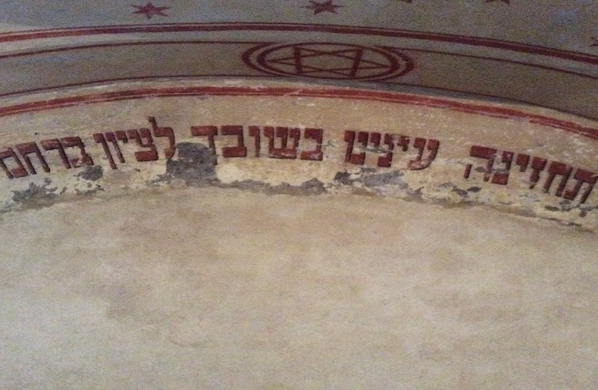

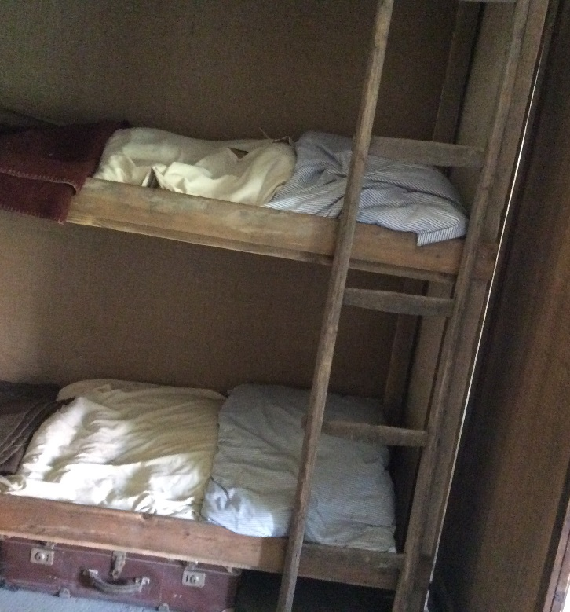

When beginning our tour, we asked our guide what she knew about Regina Jonas. She said she had never heard of her until two days before when she learned that we were coming. I found that shocking and was even more grateful that we were going to dedicate a plaque in her memory so that no guide would ever say that again. I was shocked that she was not remembered because other rabbis, chief among them Leo Baeck, were remembered with photos. In addition, we were shown four pieces of paper in Regina Jonas' own handwriting listing lectures she had given: Women and Judaism, Women and the Bible, Jewish Holidays, The Meaning of Mitzvot, etc. - all topics that female rabbis have spoken about many times, reminding us that her experience in being the first was not all that different from ours.  
  
The fact that Regina Jonas taught courses is a reminder that Jewish cultural life was very much a part of life at Terezin. There were concerts, recitals, poetry readings and opportunities for art and painting. The poem "I Never Saw Another Butterfly" was written here, as was the children's opera Brundibar (performed many times in our community, most recently under the direction of Chhange, the Center for Holocaust, Human Rights and Genocide Education at Brookdale Community College). The pianist Alice Herz-Sommer performed here many times. Last year, she died at the age of 110, believed to be the oldest known Holocaust survivor. She died the same week that a documentary about her life won an Academy Award.   
  
We were privileged to meet with Helga Hoskova, one of a hundred survivors of Terezin who are still alive. She is an artist, and her presentation to us included a few paintings on the walls of the room we were in as well as slides of some of the paintings she created while a young child at Terezin. 

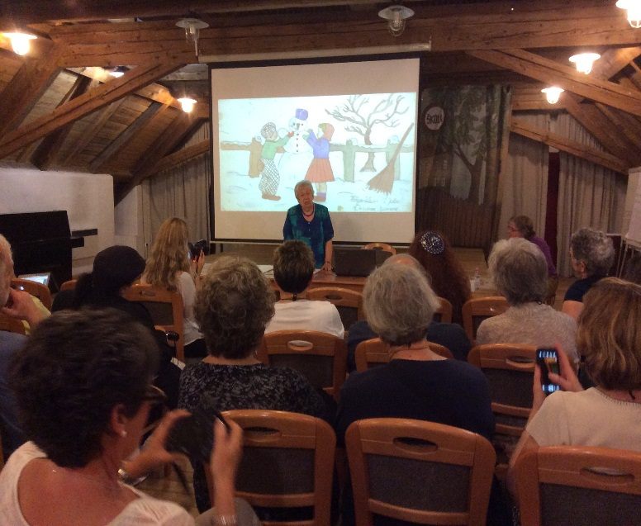

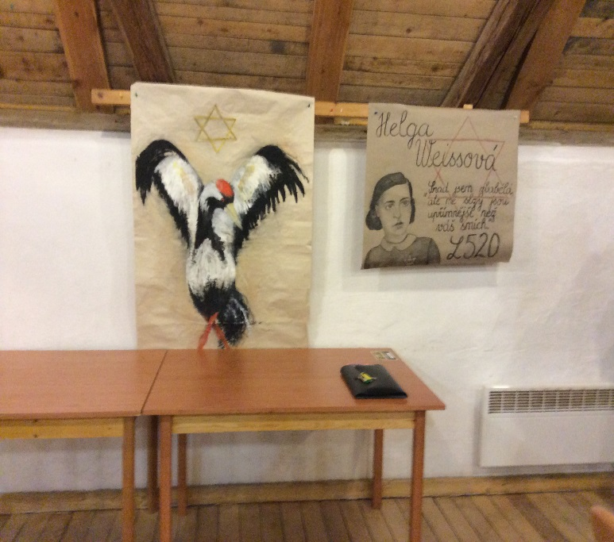

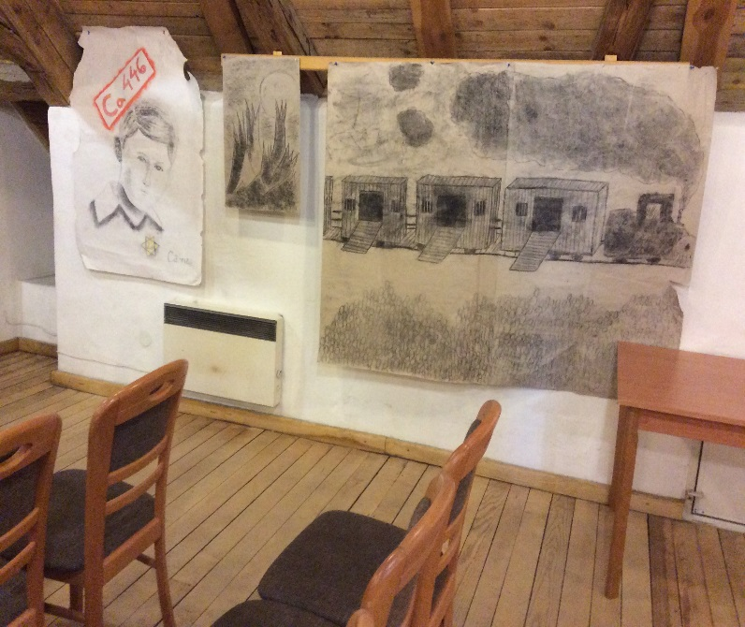

We were honored to have Helga participate in dedicating the plaque in memory of Regina Jonas and particularly pleased that her son and granddaughter provided music on violoncello, cello and organ for the ceremony. I will never again hear Kol Nidre without remembering their rendition. Helga's story reminds us that God enables ordinary people to do extraordinary things and that Holocaust survivors triumphed over Hitler by returning to life rather than retreating from it, by having children and grandchildren and showing that despite the horrors of the Holocaust there is meaning and purpose in human life.   
  
The plaque we came to dedicate hangs in the Columbarium. In addition to the music, greetings from Dr. Jan Munk and a keynote address by Ms. Lesley Weiss, chair of the U.S. Commission for the Preservation of America's Heritage Abroad, the Four Firsts each read a passage written by Regina Jonas herself. There was something quite remarkable about giving life to her words and affirming our connection to her. Rabbi Sasso wrote two very meaningful poems for the occasion, and Rabbi Eilberg chanted very beautifully El Malei Rachamim, perhaps the first time that this memorial prayer had ever been recited for Regina Jonas. The ceremony concluded as each person left behind a stone to tell others that we had been there and that Rabbi Regina Jonas has been given her rightful place among the chain of Jewish tradition that binds together all the generations of our people - past, present and future.

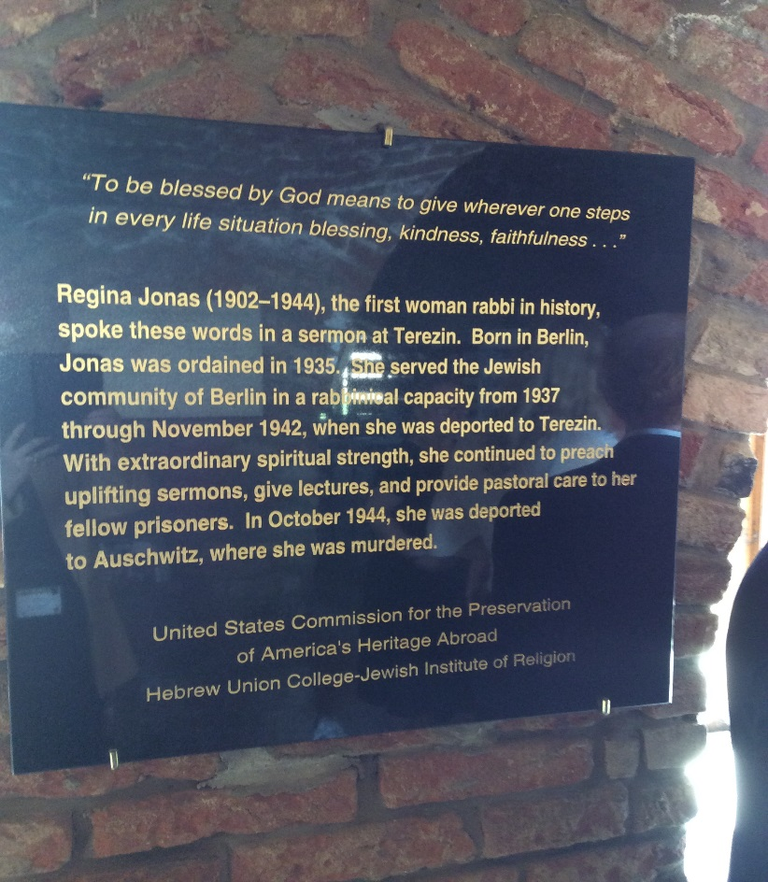

Upon leaving Terezin, we set out for Prague, had a quick dinner and then proceeded to the home of the United States Ambassador to the Czech Republic. Ambassador Norman Eisen, who is approaching the end of his term, was a charming host. He is a knowledgeable Jew and had obviously done his homework before our visit. He was also a wonderful tour guide! The house was built in the 1920s by Otto Petschek, the patriarch of a wealthy German Jewish family, who had very definite ideas about how the house should look.   
  
After Petschek's death and the departure of his family to the United States where they still live, the house was seized by the Nazis after they occupied Prague six months before the war began. Hitler thought of Prague as the city from which he would govern after winning the war. That is why very little of Prague was ever damaged or destroyed. Hitler himself gave strict orders that this house was not to be harmed in any way. During the war, Nazi aides and soldiers were housed on the property.   
  
The Ambassador had many stories to share - I sometimes wondered if they were fact or fiction! He told us that when the Petscheks left for America, their butler buried the family silver in the backyard where it remained until 1948 when the house was purchased by the American government. One member of our group asked if there were any secret doors. The Ambassador took us into the music room and opened a door he said had probably not been discovered by his predecessors. Inside was a complete collection of music and at the bottom of one stack he found a copy of Hitler's songbook. He decided to leave it in place so future generations would know what happened here. 

**FRIDAY**

On Friday morning, we set out on a six hour walking tour of Prague. It is a beautiful city which managed to survive the destruction that was common in so many European cities during World War II. All along our journey we were treated to a wide variety of architectural styles: cathedrals, spires, apartment buildings painted in a variety of colors. As in America, we encountered several street performers along the way.

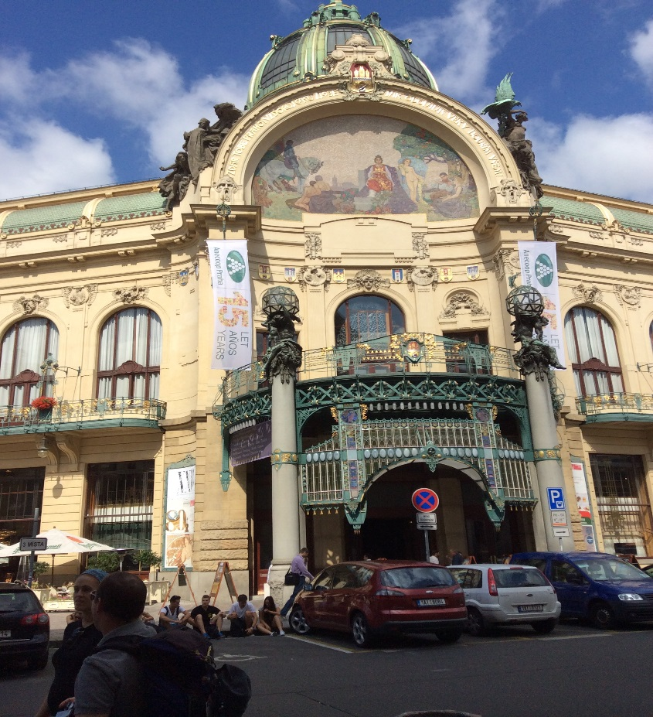

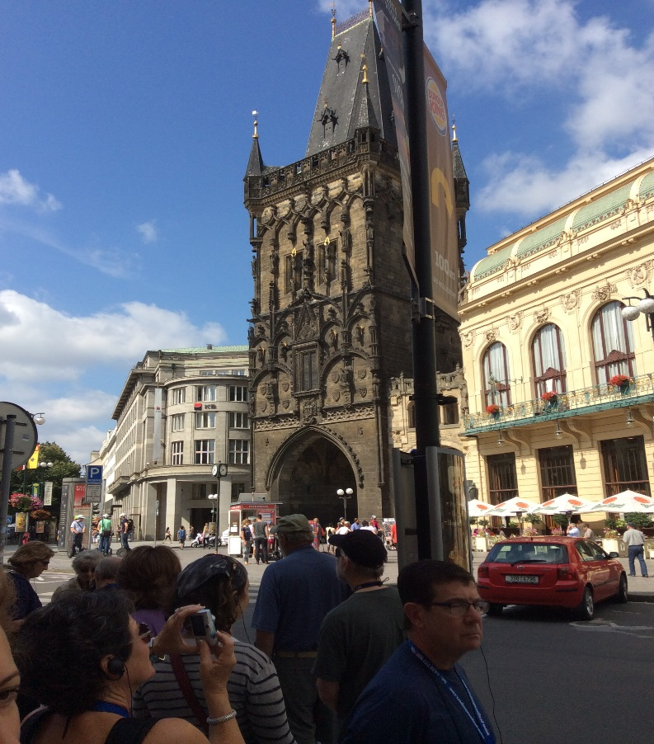

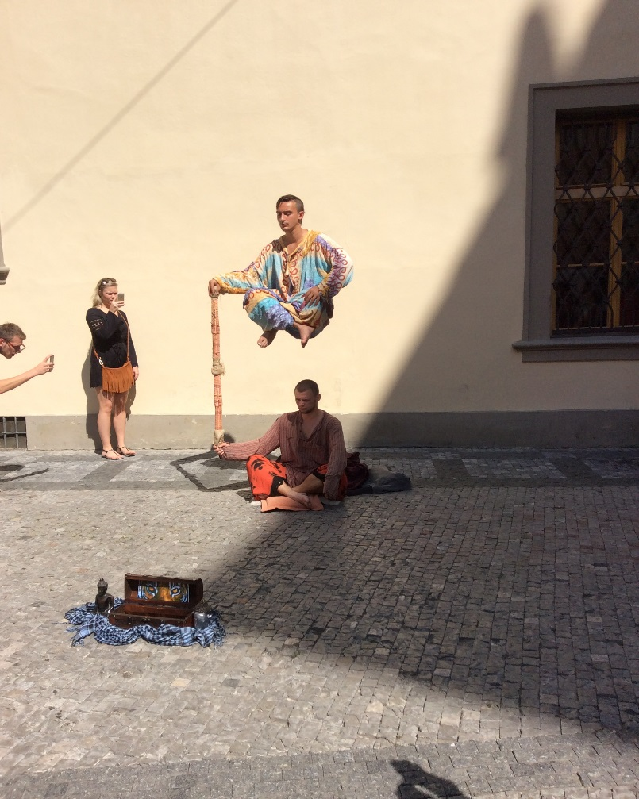

The Old Town Square was packed with people. We happened to arrive just in time to see the astronomical clock strike the hour with its procession of apostles and the crowing of the golden rooster.

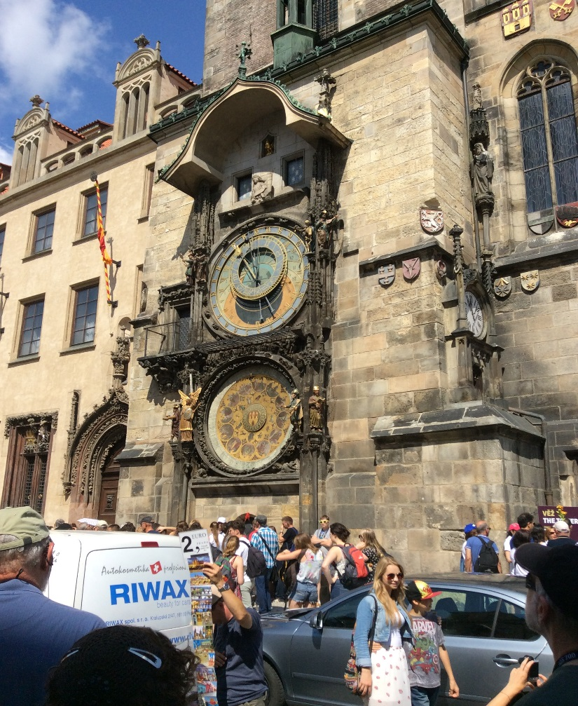

Crossing through the square we approached the Jewish Quarter where we saw the first of many mentions of Franz Kafka who was born here. He became Bar Mitzvah at the Old-New Synagogue.

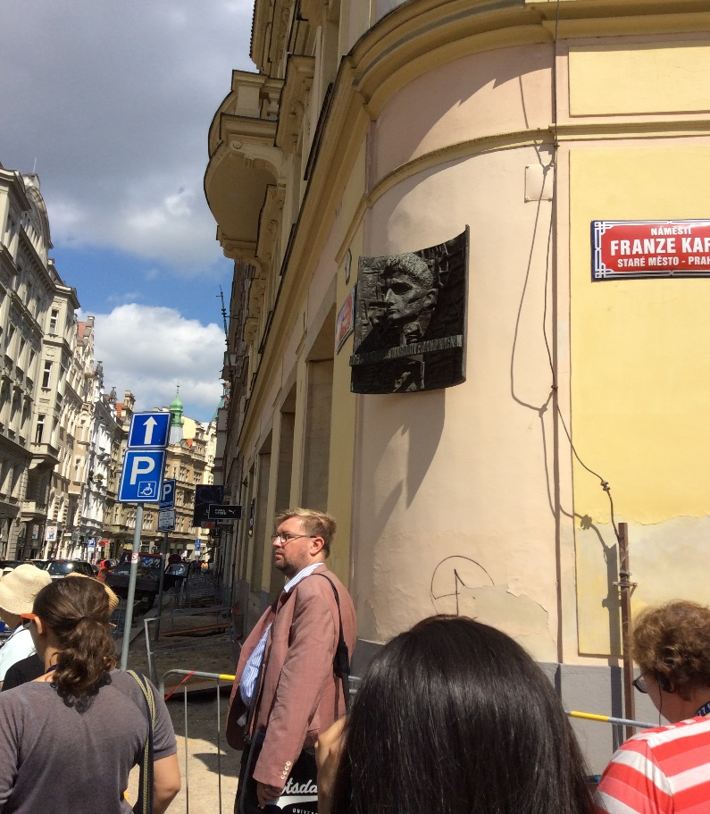

Nowhere in Europe is there a Jewish Quarter that rivals this one in terms of preservation.  There are six synagogues, the Old Jewish Cemetery and the old Jewish Town Hall. We did not have time to visit everything, and I respected the signs inside the synagogues asking us not to take pictures. The Maisel Synagogue was financed by Mordechai Maisel, mayor of Jewish Town in the late sixteenth century. Today it is used as the Jewish Museum, housing many of the ritual objects that the Nazis had planned to display as relics of an exterminated people.   
  
The Pinkas Synagogue is a powerful reminder of all that we lost during the Shoah. On white walls it lists nearly 80,000 names, written by hand and without templates, remembering the Jews of Czechoslavakia who were murdered during the Holocaust. This was one of many instances I noticed during the trip in which efforts were made to remember that the victims were human beings with names and not just numbers.   
  
As we proceeded to the Old Jewish Cemetery, we noticed a mikvah, underground and not open to the public. The cemetery is quite old and the tombstones are in disarray, probably because people are buried on top of each other.  Over the centuries, soil was brought in to create new layers when needed, and periodically the older tombstones pop up through these newer layers.

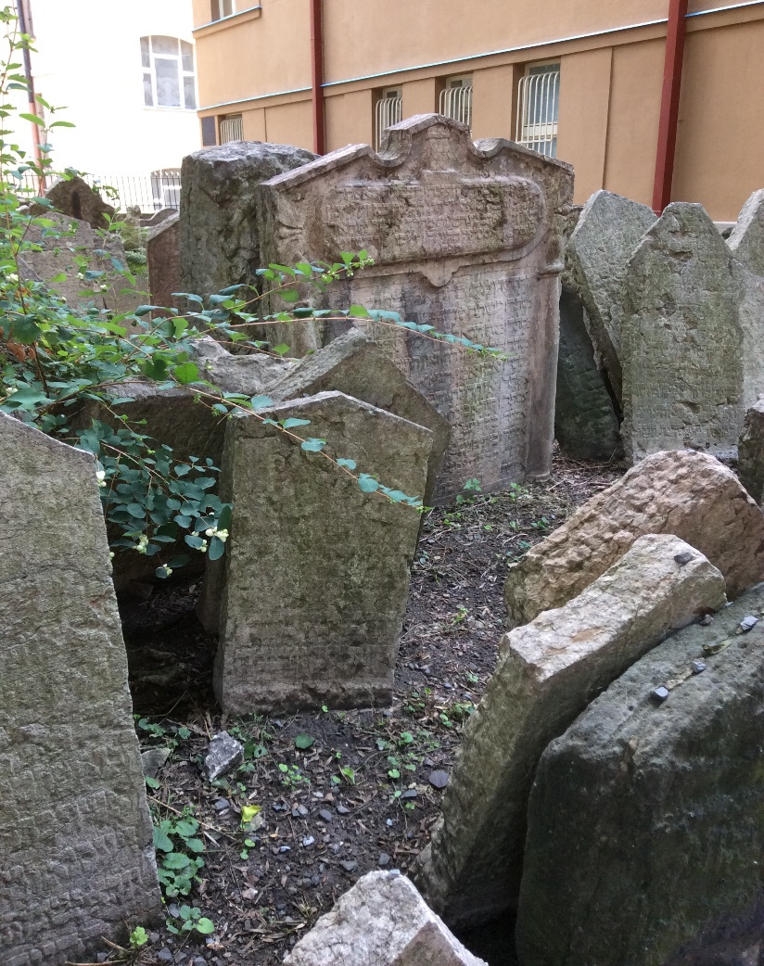  
  
The most famous person buried here is Rabbi Judah Loew, also known as the Maharal, creator of the Golem, a clay giant meant to protect Jews in the Prague ghetto from pogroms and other anti-Semitic attacks. The Maharal was believed to have mystical powers, and he was well-respected for his knowledge and scholarship among both Jews and non-Jews. His grave is visited frequently by those seeking advice and guidance. His wife Pearl is buried next to him.

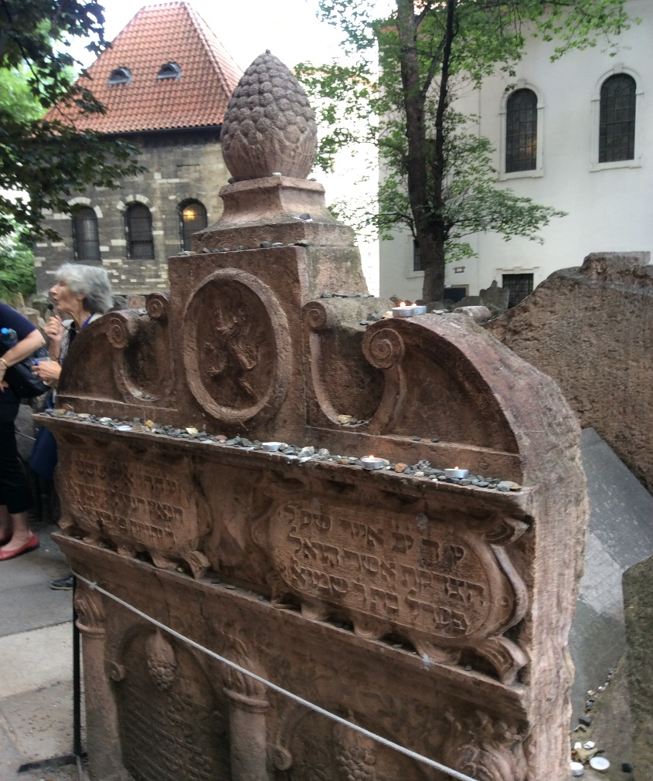

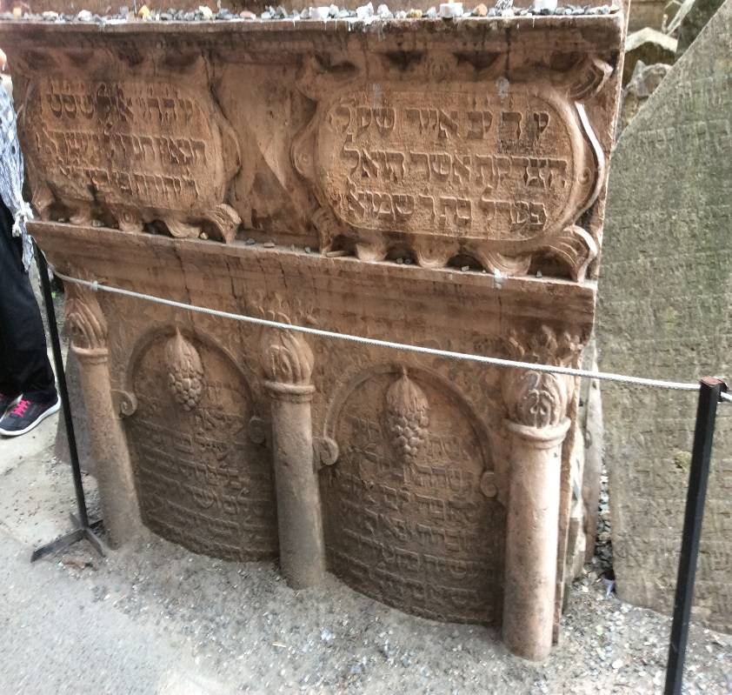  
  
The Altneuschul, or Old-New Synagogue, is the oldest synagogue still in use in all of Europe, and the only surviving one of Gothic architecture with a medieval double-nave. The Maharal served here as Chief Rabbi, and legend has it that when the Golem became violent and had to be destroyed, its remains were stored in the synagogue's attic. To this day, there is a chair set aside in the sanctuary for the Maharal. There is also a chair for the U.S. Ambassador to the Czech Republic. The women's gallery, or ezrat nashim, is hidden from view, but if you look closely you will see narrow, horizontal slits in the wall surrounding the sanctuary from which women could watch the services.   
  
One of the symbols we saw quite often as we walked from one building to the next was a Star of David with a hat in the middle. This is a reminder of the unique hat Jews had to wear whenever they left the ghetto.

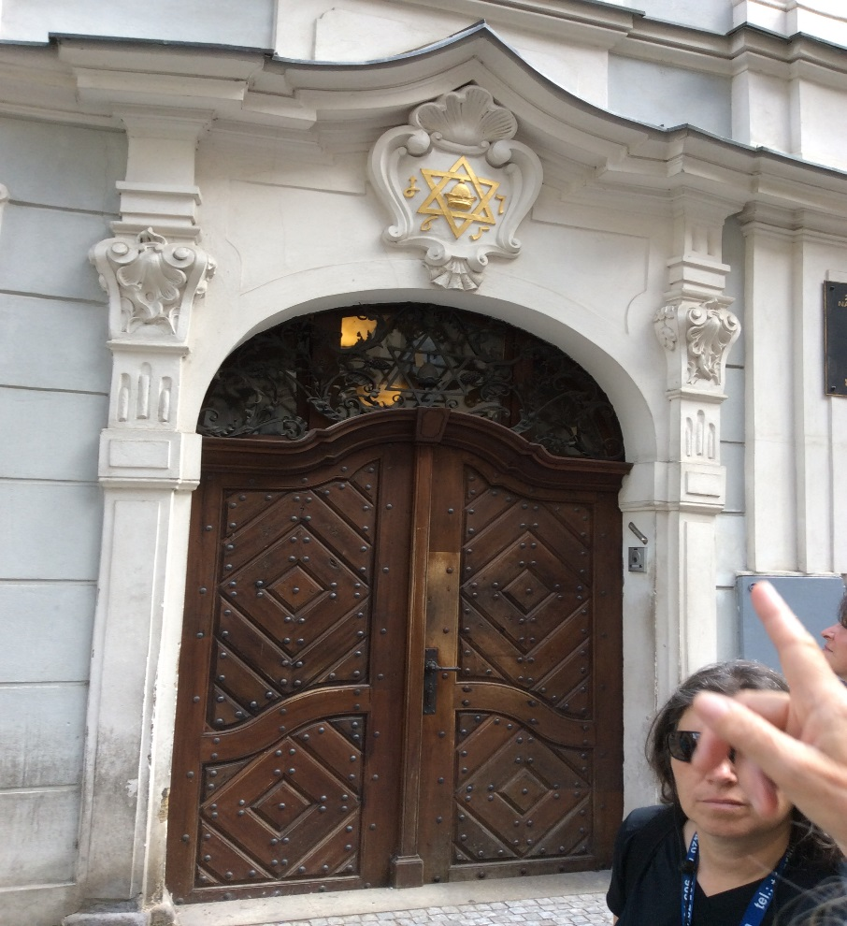

The Old Jewish Town Hall, where Jews gathered for community meetings, is closed to the public. Nonetheless, its most interesting feature is on the outside: a clock high up with Hebrew numerals that runs counterclockwise (sorry for the poor quality of the photo, but you get the idea!).

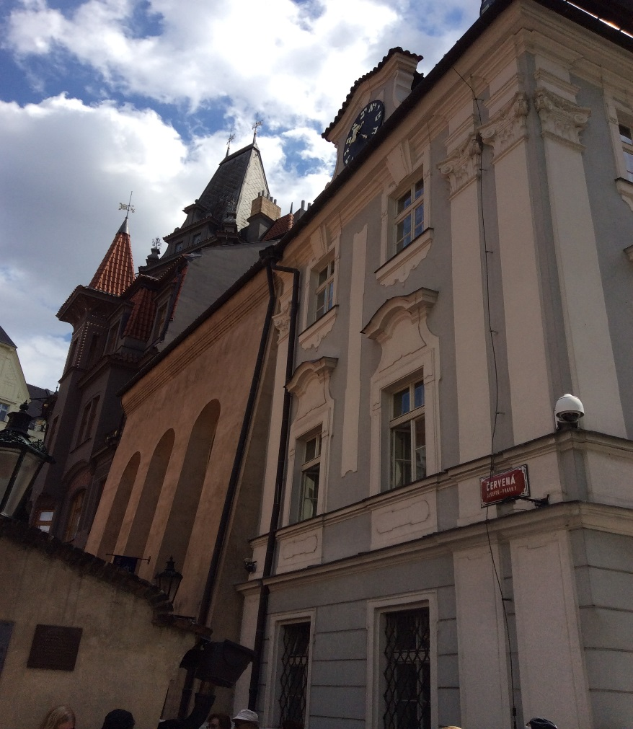  
  
The legend of the Golem is everywhere, including clay figures sold by street vendors. As we entered the Jewish Quarter, I noticed this restaurant.

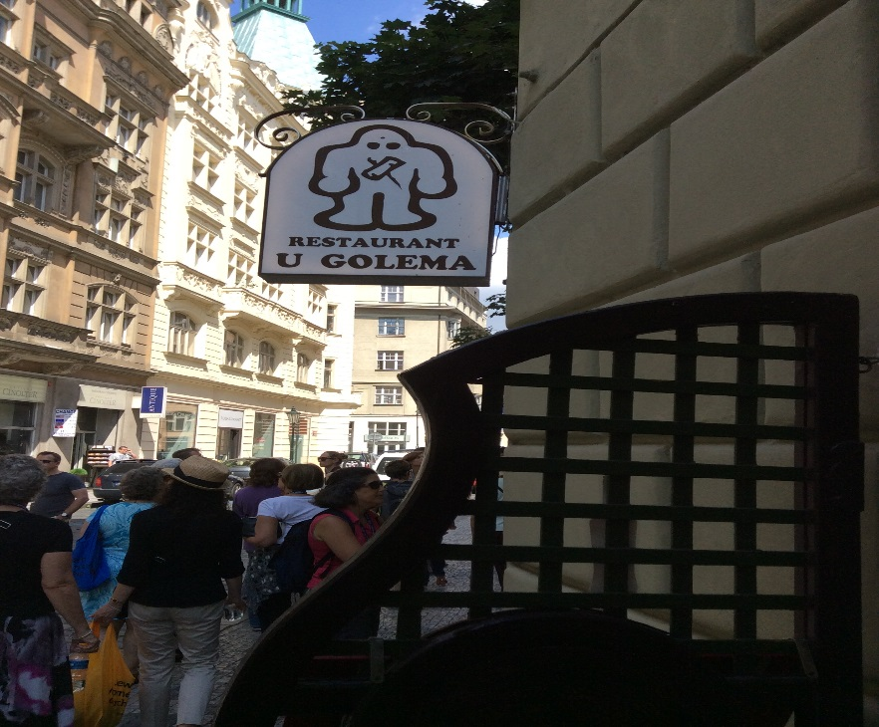  
  
On Friday evening, we celebrated Shabbat with Bejt Simcha, a liberal congregation affiliated with the World Union for Progressive Judaism. Before the service began, we enjoyed two study sessions, one led by Rabba Hurwitz about Yalta, a little known woman mentioned in the Talmud, and the other led by Rabbi Eilberg about the meaning of memory.   
  
The congregation rents space in the basement of a building on one of the main streets in the Jewish Quarter just beyond the Old Town Square. The prayer book we used was created by the congregation and contained prayers in Czech, Hebrew and English.  The D'var Torah about the daughters of Zelophechad was presented by one of the lay members of our group who did an excellent job. The Oneg Shabbat gave us an opportunity to meet members of the congregation. All in all, it was a delightful and meaningful way to begin Shabbat.  
  
We then proceeded to the King Solomon Restaurant, glatt kosher, where we were treated to a traditional Shabbat dinner. It was as if we were one big family enjoying dinner, singing songs, telling stories, reflecting and laughing together.

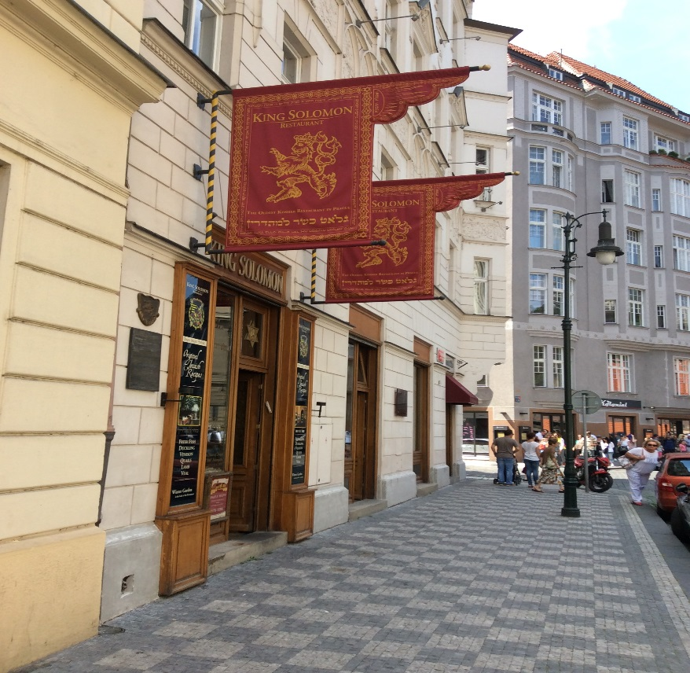

**SATURDAY**On Saturday morning, we were privileged to be given the Spanish Synagogue for our service. It is a beautiful synagogue in the Moorish tradition, very similar to Cincinnati's Plum Street Temple where I was ordained. The main difference is that whereas Plum Street is very large, this was quite intimate with only five rows of pews. Rabba Hurwitz went first to the Old-New Synagogue and then joined us, bringing with her the U.S. Ambassador's wife and daughter whom we had met on Thursday evening - and soon thereafter the Ambassador himself stopped in to wish us all Shabbat shalom!   
  
I was responsible for planning the service and finding a way for each of the Four Firsts to participate in a way that was meaningful for her. I suspect that this was the first time that four rabbis of different denominations led a Shabbat service together, making this an historic experience. We used Mishkan T'filah for Travelers which proved to be a perfect siddur for people with different customs and theologies. Rabbi Eilberg davened Birchot HaShachar and Pesukei D'Zimrah, then led the music as I read the next part of the service.   
  
I offered a sermon linking the daughters of Zelophechad to Regina Jonas and ending with some thoughts about Monmouth Reform Temple’s Holocaust Torah which came to us from the Czech Memorial Scrolls Trust. Then Rabbi Eilberg chanted Torah, and we honored three of our group with aliyot: Andy Berger, newly elected chair of the Board of Governors of HUC-JIR; Rabbi Denise Eger, president-elect of the CCAR; and Rabbi Kinneret Shiryon, the first woman to serve as rabbi in the State of Israel. As we put the Torah away, Rabbi Dennis Sasso, who comes from Panama, taught us a Spanish-Portuguese melody for V'zot HaTorah.   
  
Following the Torah service, Rabbi Sandy Sasso shared her study session about the Akedah and its relationship to art and memory. Then she and her husband led the concluding prayers, and Rabba Hurwitz offered the closing prayer based on the coming of the new month. Marta, the mother of the synagogue's president (who was on vacation), was a very gracious hostess and made certain that we had everything we needed. We concluded with kiddush and challah.   
  
Our afternoon tour was of the Prague Castle, the largest castle complex in the world including a variety of palaces and ecclesiastical buildings, courtyards and alleyways. Today it is the seat of the head of state, and the Crown Jewels are kept here. The property is the size of seven football fields - no one was more surprised than I that I had enough energy to walk this site! As we approached the main building, we were greeted by the soldiers of the elite Castle Guard, arriving just in time to witness the Changing of the Guard (sorry, no zoom lens on my iPad!)

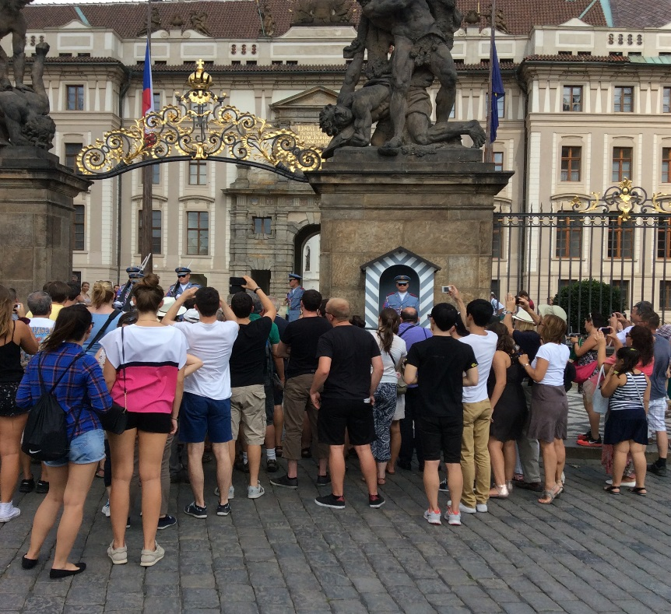

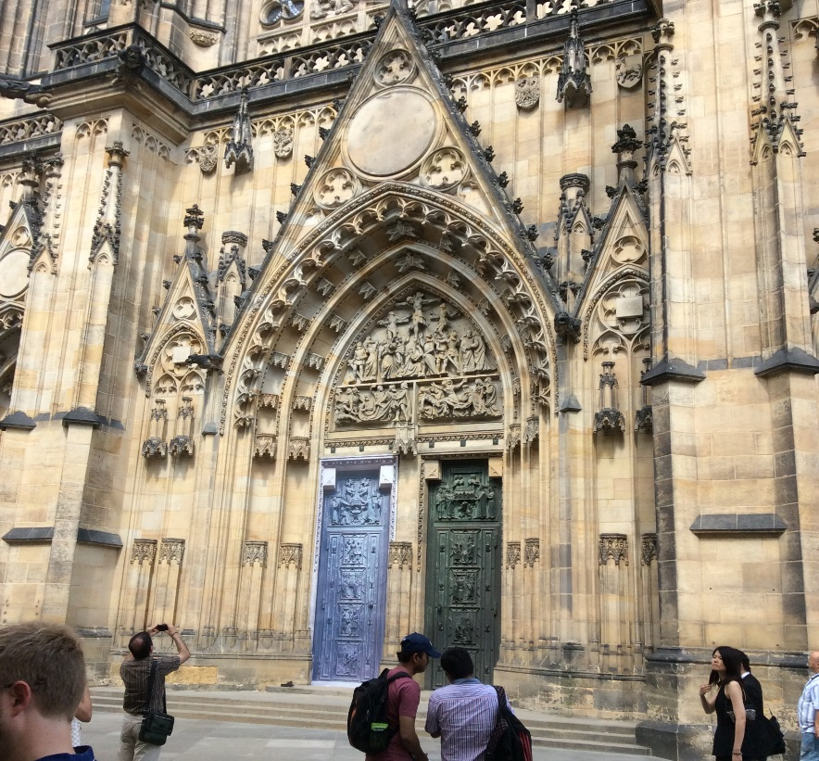

Words cannot do justice to the beauty of the St. Vitus Cathedral. As you enter, the sun lights up the beautiful stained glass windows, some of which are created in the style of art nouveau. Here you will find the tombs of Czech rulers and important saints like St. Wenceslas, Charles IV and Rudolf II. If your interest is architecture, this is like a textbook: Romanesque, Gothic, Baroque, Renaissance - all are represented here. There are museums, gardens, exhibit spaces and art galleries. I regret that I was too tired to walk the steps to the Golden Lane, a row of colorful miniature houses in one of which Franz Kafka worked.   
  
I enjoyed the view from the top of the hill overlooking the city, and got a close up of the soldier standing guard. One would need at least two days, maybe three, to see all that is offered here.

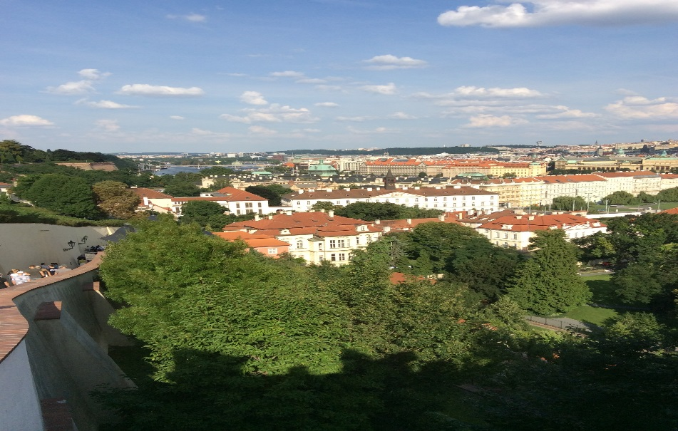

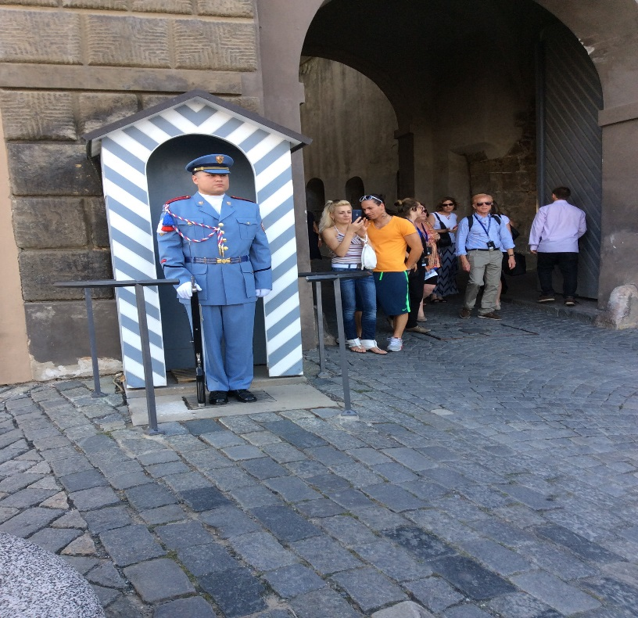

Being at the top of the hill means, of course, that you have to walk down the hill! It was very steep, but fortunately there was a handrail and I went slowly. I was grateful that my dear friends, Dorothy and Leonard Teitelbaum, came on the trip and watched out for me wherever we went. After making it to the bottom of the hill, they invited me to join them for dinner near the Charles Bridge, one of the most popular sites in Prague. It is a walking bridge over the Vltava River lined with Baroque statues, artists, musicians and vendors.   
  
As it turns out, we never quite made it to the bridge - probably a good thing because I don't think I could have walked another step! We stopped instead at a restaurant called the Bellevue overlooking the river. It turned out to be quite elegant with a very creative approach to food and wine. When we asked what Buddha's finger was, the waiter pulled out an iPad and showed us a picture. Leonard and I were particularly pleased with the dessert which we shared: a delicious concoction of chocolate cream, caramel, banana ice cream and popcorn.  I found out later that the New York Times considers this to be the best restaurant in Prague - and to think we found it by accident!   
  
After dinner, we joined the rest of our group for our final session together. We sat in a circle and shared with each other the highlights of our trip. As it turned out, I was seated at the end of the circle where I had an opportunity to hear what everyone else said before I spoke. It was clear to me that all of us had been profoundly moved by this experience. I remembered a quote from Elie Wiesel: To be a Jew today is to remember what is and what is no more. We saw for ourselves the vitality of Jewish life today and we remembered all that we lost during the Shoah. Someone suggested that from year to year we should observe the yahrzeit of Rabbi Regina Jonas. I think that is a wonderful idea. It will serve as a reminder of her contributions to Jewish life and of all that we experienced during this very special tine together.